Rc
Ic
Ut
Rc
R1
Ib
UR
R2
Rb
Re
UReEEec
Re
Ie

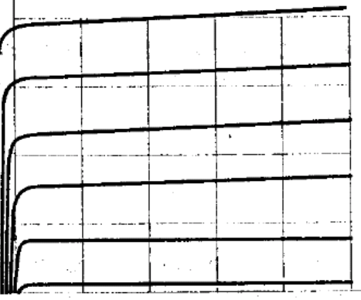
RC=2,2KΩ
RE=0,047kΩ
B=120
UT=12V
UBE=0,7V
USAT=0,2V

ICMAX = 5,251 mA
ICMP = 2,6255 mA
IE = 2,6378 mA
IB = 0,0218 mA
IR1= 0,218V
IR2 = 0,218V
UE = 0,1239V
UB = 0,8239V
UC = 6,1864V
UR1 = 11,1761V
UR2 = 0,8239V
UAB = 11,0915
UCE = 6,0445V
URC = 5,8316V
R1 = 51,2665KΩ
R2 = 4,1992KΩ

Icmax = $\frac{Ut-Usat}{Rc+Re}$ = $\frac{12-0,2}{2,2+0,047}$ = $\frac{11,8}{2,247}$ = 5,251 mA
Icmp = $\frac{Icmax}{2}$ = $\frac{5,251}{2}$ = 2,6255 mA
IB =$\frac{Ic}{B}$ =$\frac{2,6255}{120}$ = 0,0218 mA
IE = (1+B)*IB =(1+120)*0,0218 = 2,6378 mA
IE = Ic + IB =2,6255 + 0,0218 = 2,6473 mA
UE = RE * IE =0,047*2,6378 = 0,1239V
UB =UE + UBe = 0,1239 + 0,7 = 0,8239V
UR2 = UB = 0,8239V
UR1 = UT – UR2 = 12 – 0,8239 =11,1761 V
IR1 = 10*IB = 10*0,0218 = 0,218V
R1 = $\frac{UR1}{IR1}$ = $\frac{11,1761}{0,218}$ = 51,2665KΩ
R2 =$\frac{UR2}{IR2}$ = $\frac{0,8239}{0,1962}$ = 4,1992KΩ
URC = IE *RC = 2,2 * 26378 = 5,8316V
UC = UT – URC =12 - 5,8316 = 6,1684V
UCE = UC – UE = 6,1684 – 0,1239 = 6,0445V
UAB = U*$\frac{R1}{R1+R2}$ =12*$\frac{51,2665}{51,2665+4,1992}$ = 11,0915V

